Assignment 1: Observability
Gym Tracker: metrics and logs for a journal-first training log
Sohaib Muhammad
sm09751

Part A: Project
Problem. Most people who lift keep their training log as free text, something like “bench 60x8, 70x6”. It's quick to write, but you can't do much with it later. Apps that make you tap in every set give you clean data, but they're tedious, and people tend to stop using them.
Intended users. Anyone who keeps their own training log. Several people can use the same deployment, and each person only sees their own data.
Solution. A web app (FastAPI and Postgres) that sits in the middle. You paste your entry the way you normally write it, and a language model (Groq) turns it into individual sets. You check every row before anything is saved. After that, the data feeds the progress charts and a weekly report.
What works. The core app works: parsing, review before saving, duplicate detection, accounts, progress charts and the weekly report. The monitoring side added for this assignment includes Prometheus metrics, logs shipped to Elasticsearch, three Grafana dashboards, Node Exporter for host stats, a fault-injection switch and a cardinality demo. Parsing needs a Groq API key, but everything else runs without one. One thing is still missing: sets logged from the newer live-workout screen aren't counted in gym_sets_written_total.
How to try it. Everything is in README.md, but here's the short version. docker compose up -d --build starts the app, the database and the six monitoring services, and ./scripts/setup_kibana.sh sets up Kibana's saved searches. To generate some traffic, run python scripts/load_generator.py --duration 120 --rps 5. Tests run with pytest -q after installing requirements-dev.txt (1045 pass, 18 are skipped). When you're done, ./scripts/stack.sh down stops everything and keeps the data, while ./scripts/stack.sh destroy wipes it too.
Once running, the app is at http://localhost:8000, Prometheus at :9090, Grafana at :3000 and Kibana at :5601.

Part B: Metrics
Prometheus is the part that collects the numbers. Every 15 seconds it asks the app (at /metrics) and Node Exporter for their current values, and it keeps 15 days of history. Grafana turns those numbers into three dashboards, and the dashboard definitions are stored as files in the repo, so they're versioned with the code. The app exposes 19 metrics in total. Table B.1 on the next page lists them, and they cover all four metric types.

Table B.1. Queries are copied exactly from the dashboards. Two gauges are exposed but not charted. p95/p99 come from the histograms.
Metric | Kind | Type | Unit | Labels | Purpose | Recorded in code (how) | Grafana query
gym_http_requests_total | App | Counter | requests | method, route, status | Every response; both sides of the error rate | app.py:459 .inc() (419 on exceptions) | sum by (route) (rate(gym_http_requests_total[1m]))
gym_http_exceptions_total | App | Counter | exceptions | route, exception | Unhandled exceptions, told apart from deliberate 500s | app.py:422 .inc() | sum by (route, exception) (rate(gym_http_exceptions_total[5m])) or vector(0)
gym_http_requests_in_flight | App | Gauge | requests | none | Requests being served now (saturation) | app.py:377 .inc(), 447 .dec() | gym_http_requests_in_flight
gym_http_request_duration_seconds | App | Histogram | seconds | method, route | Request latency; source of p50/p95/p99 | app.py:456 .observe() (416 on exceptions) | histogram_quantile(0.95, sum by (le) (rate(gym_http_request_duration_seconds_bucket[5m])))
gym_db_commit_duration_seconds | App | Histogram | seconds | none | Time spent in the saving transaction | app.py:1356 observe_duration() | histogram_quantile(0.95, sum by (le) (rate(gym_db_commit_duration_seconds_bucket[5m])))
gym_logins_total | App | Counter | attempts | result | Logins: success, failure, rate-limited | app.py:851, 874, 889 .inc() | sum by (result) (increase(gym_logins_total[5m]))
gym_build_info | App | Gauge | 1 | version, commit | Which build is running (always 1) | metrics.py:390 set_build_info() at startup | not charted
gym_faults_injected_total | App | Counter | faults | kind | When the Part E fault was live | faults.py:138 .inc() | sum by (kind) (increase(gym_faults_injected_total[1m]))
gym_workout_entries_total | Business | Counter | entries | outcome | Entries saved, blocked or held as duplicates | app.py:1397, 1332, 1374 .inc() | sum by (outcome) (increase(gym_workout_entries_total[5m]))
gym_sets_written_total | Business | Counter | sets | none | Sets saved: the product's unit of value | app.py:1400 .inc(inserted_sets) | increase(gym_sets_written_total[24h])
gym_bodyweight_entries_written_total | Business | Counter | readings | none | Bodyweight readings saved | app.py:1401 .inc() | sum(rate(gym_bodyweight_entries_written_total[5m])) * 60
gym_duplicate_decisions_total | Business | Counter | decisions | decision | How the duplicate prompt was answered | app.py:1375, 1349 .inc() | sum by (decision) (increase(gym_duplicate_decisions_total[10m]))
gym_review_drafts_open | Business | Gauge | drafts | none | Parsed entries waiting for review | metrics.py:463 .set(), from app.py:1272 (open) and 1406 (close) | gym_review_drafts_open
gym_llm_extractions_total | Business | Counter | calls | outcome | Groq calls: success, rate-limited, error | pipeline.py:1050 .inc() | sum by (outcome) (increase(gym_llm_extractions_total[5m]))
gym_llm_extractions_in_flight | Business | Gauge | calls | none | Groq calls in progress | pipeline.py:1187 .inc(), 1224 .dec() | not charted
gym_llm_extraction_duration_seconds | Business | Histogram | seconds | none | Groq extraction time, retries included | pipeline.py:1051 .observe() | histogram_quantile(0.95, sum by (le) (rate(gym_llm_extraction_duration_seconds_bucket[10m])))
gym_weekly_reports_total | Business | Counter | reports | narration | Weekly reports, and whether narration worked | app.py:1509 .inc() | sum by (narration) (increase(gym_weekly_reports_total[1h]))
gym_entry_text_bytes | Business | Summary | bytes | none | Size of pasted entries (drives LLM cost) | app.py:1264 .observe() | rate(gym_entry_text_bytes_sum[30m]) / clamp_min(rate(gym_entry_text_bytes_count[30m]), 0.0001)
gym_sets_per_entry | Business | Summary | sets | none | Sets per saved entry | app.py:1402 .observe() | rate(gym_sets_per_entry_sum[30m]) / clamp_min(rate(gym_sets_per_entry_count[30m]), 0.0001)

Percentiles and the time window
Percentiles come from histograms, looking at a sliding 5-minute window: histogram_quantile(0.95, sum by (le) (rate(gym_http_request_duration_seconds_bucket[5m]))).
In plain terms, p95 means “95% of requests in the last 5 minutes finished within this time”. Picking the window is a trade-off. A shorter window reacts faster but jumps around more, and since Prometheus only samples every 15 seconds, anything under a minute doesn't have enough data points to trust. Summary metrics in the Python client can't produce percentiles, so those two are shown as averages instead.

Dashboards
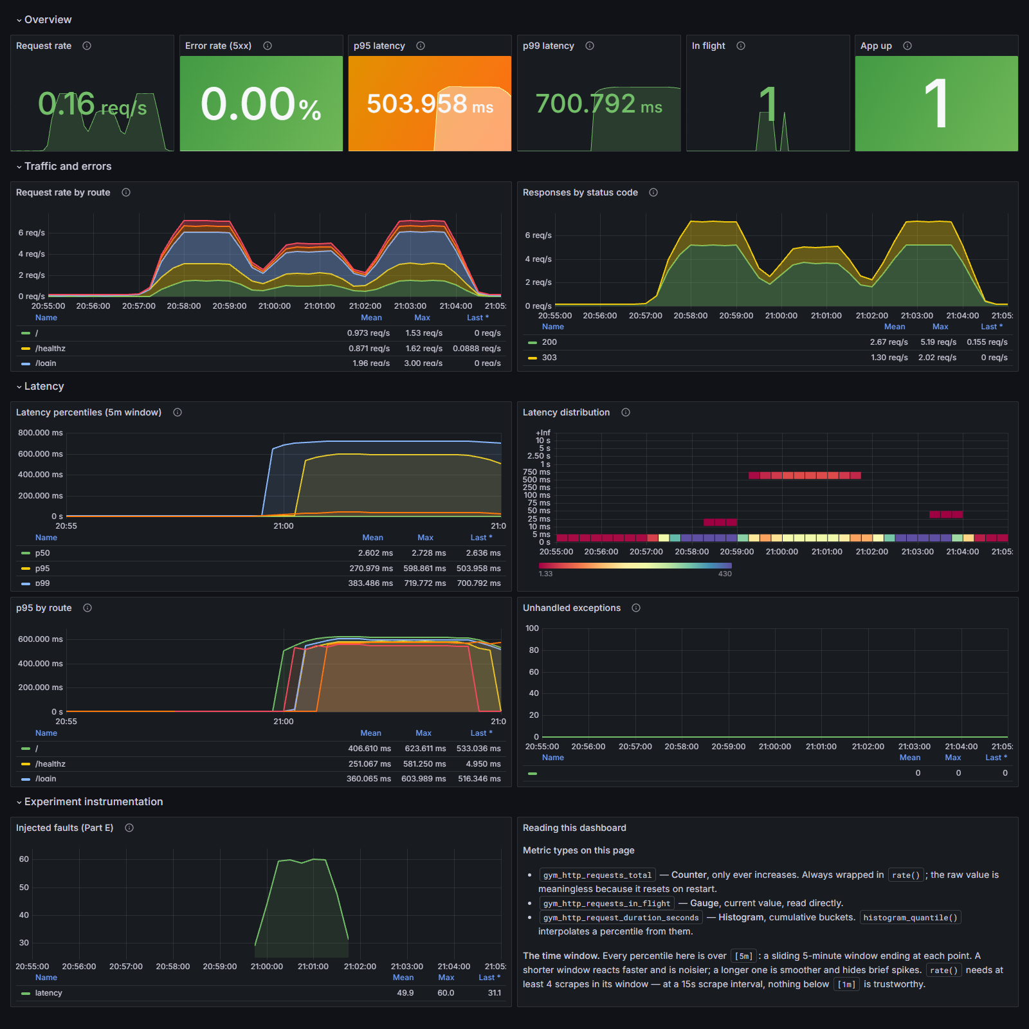
Screenshot 1: Application dashboard (rate, errors, duration), captured during the Part E fault experiment on 19 September.
What it shows. Request rate, error rate, latency percentiles, requests in flight and uptime. This screenshot was taken with the fault switched on. p95 and p99 jump to roughly 500 and 700 ms, but p50 stays at 2.6 ms and there are no errors, so the percentile panels are the only ones showing a problem. The heatmap makes it visible too: it splits into two bands, fast requests and slow ones.
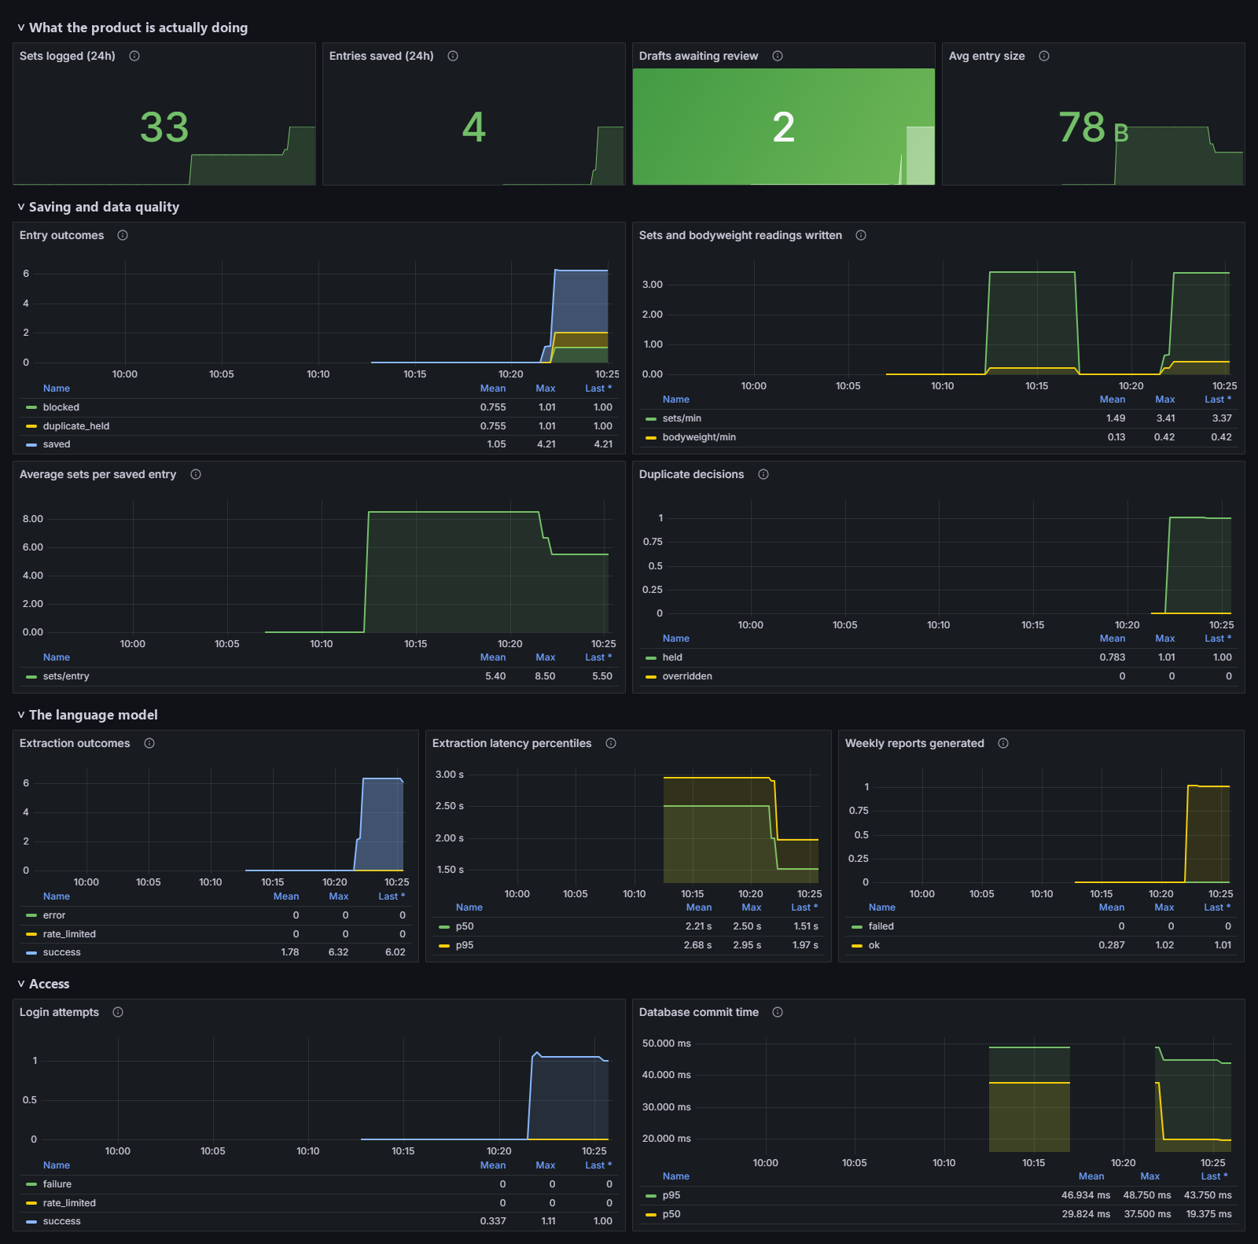
Screenshot 2: Business dashboard after six journal entries were pasted, parsed by Groq and reviewed (21 September).
What it shows. Six entries went through the full flow: 4 saved, 1 held as a duplicate and 1 blocked at review. Groq handled all six extractions, with p95 around 2 s. One weekly report was generated, and 2 drafts are still waiting for review (the held and blocked ones). One number looks off at first: “Sets logged” shows 33, not 16. The extra 17 come from two entries saved earlier that day, before an app restart (Part D walks through this). “Entries saved” shows only 4 because those earlier saves happened before a fix to how labelled counters start (details in REPORT.md).
Metric I explored myself: gym_sets_per_entry (a Summary). This one catches a quiet failure. If the model started dropping rows while parsing, entries saved and sets written would both still look normal, but the average number of sets per entry would fall. In Screenshot 2 it reads 5.5.

Node Exporter: the machine
Node Exporter measures the machine everything runs on, which here is the Docker Desktop WSL2 Linux VM (12 cores, 7.56 GiB RAM). It's labelled machine="docker-host" and scraped at 172.28.77.1:9100.
Resource | Grafana query | In Screenshot 3
CPU | 1 - avg(rate(node_cpu_seconds_total{mode="idle"}[5m])) | 2.98% busy
Memory | 1 - (node_memory_MemAvailable_bytes / node_memory_MemTotal_bytes) | 38.15% of 7.56 GiB
Disk | 1 - (node_filesystem_avail_bytes{mountpoint=~"/|/var/lib"} / node_filesystem_size_bytes{mountpoint=~"/|/var/lib"}) | 6.29% used
Network | sum by (device) (rate(node_network_receive_bytes_total{device!="lo"}[5m])) | up to 46.6 kB/s

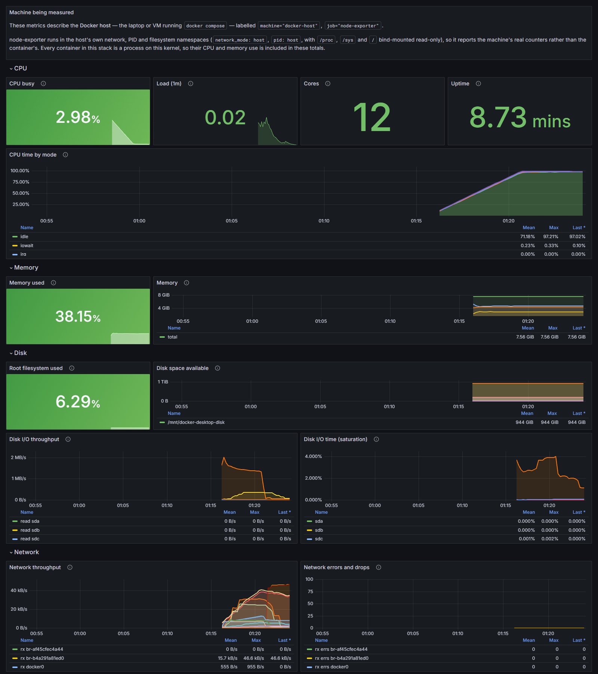
Screenshot 3: Host dashboard showing CPU, memory, disk and network from Node Exporter.

Part C: Logs
Logs take a different route from metrics. The app prints one JSON line per event, Docker saves those lines to a file, Filebeat picks them up and parses them, Elasticsearch stores them, and Kibana is where I search them.

What is logged, why, and where
Event | Why | Where in the code
request served: method, route, status, duration | One line per request, from the one place every request passes | app.py:463
request failed: exception type, message, stack | Unhandled errors, with the request they belong to | app.py:425
journal entry drafted / saved (sets inserted) | The core business events | app.py:1274, 1408
login succeeded / failed (no username) | Security signal | app.py:890, 875
extraction attempt failed / unavailable | Why the LLM step failed | pipeline.py:1202, 1743
injected fault (kind, sequence) | Makes the Part E fault visible | faults.py:168

Every line carries @timestamp (time), service.name (service), log.level (severity), message and http.request.id (request ID). The request ID is set once when a request comes in, so every line that request produces shares it. That's what makes it possible to pull up everything about one request later.
No secrets or personal data. The app logs IDs and counts, never the text of anyone's journal. As a second layer, a filter on the log handler (SensitiveDataFilter in logging_setup.py) blanks out passwords, tokens, cookies, API keys and journal text, and removes anything that looks like a key from messages and stack traces. There's a test for each case.

How Filebeat collects and parses
Filebeat watches Docker for containers labelled co.elastic.logs/enabled=true and reads their log files. It strips off the wrapper Docker adds around each line, then parses the app's JSON into proper fields. That parsing is why status and duration are stored as numbers and the request ID as an exact-match keyword, which is what makes them searchable and chartable (config in observability/filebeat/filebeat.yml).
The parsing step (decode_json_fields) has three settings worth knowing: it reads the message field, puts the app's keys at the top level instead of nesting them, and keeps the app's own timestamp rather than replacing it with Docker's.

Where logs live, restarts and deletion
Stage | Where | Survives a restart? | Deleted when
Log file | Docker, /var/lib/docker/containers/<id>/ | Yes, until the container is removed | Rotated at 10 MB, 3 files kept
Filebeat position | filebeat-data volume | Yes, so Filebeat resumes where it stopped | n/a
Stored log | Elasticsearch, elasticsearch-data volume | Yes | ILM rolls the index over daily (or at 1 GB) and deletes it 7 days later

docker compose down keeps the volumes; docker compose down -v deletes them.

Searching in Kibana
One request: copy the x-request-id header from the response, or an ID from any log line, and search http.request.id: "259fd665642941e0" (Screenshot 4). An error: search log.level: "error", check error.type to see what went wrong, then search that line's request ID to see the whole request around it. Eight saved searches come with the repo (observability/kibana/saved-objects.ndjson).

One log, its stored fields, and a working search
To show the pipeline end to end, here's one real request: GET /login on 22 September. Every stage is saved in observability/results-rerun/log-trace-example.json.
The app wrote it as a single JSON line. It includes the time (2026-09-22T09:12:17.329Z), level info, the message “request served”, the service name and version, where in the code it came from (app.py line 463), the request ID 259fd665642941e0, method GET, route /login, status 200, and a duration of 191.5 ms.
By the time it reaches Elasticsearch, Docker's wrapper is gone, each value has a proper type, Docker has added some metadata, and dotted names like http.request.id are nested into objects (http → request → id):
Field | Value | Elasticsearch type
@timestamp | 2026-09-22T09:12:17.329Z | date
log.level | info | keyword
message | request served | match_only_text
http.request.id | 259fd665642941e0 | keyword
url.path | /login | wildcard
http.response.status_code | 200 | long
event.duration_ms | 191.5 | float
container.name | gym-tracker (added by Filebeat) | keyword

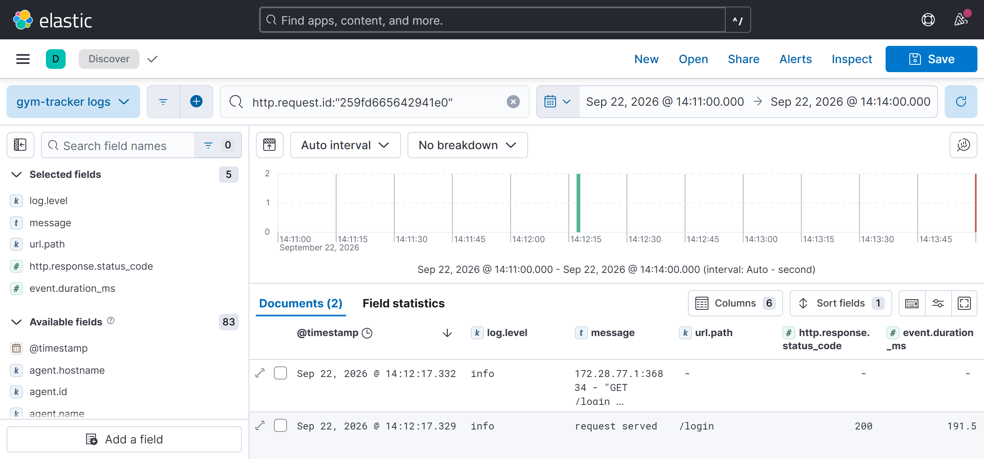
Screenshot 4: Working search. Querying http.request.id: "259fd665642941e0" returns this request’s two lines, the app’s request log and uvicorn’s access log. The field icons (k, t, #) show typed fields.

Part D: System design
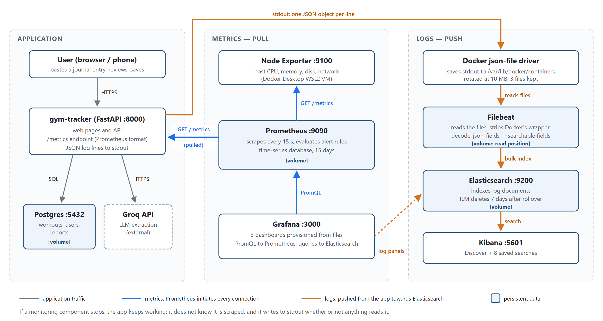
Figure 1: Architecture. Blue: metrics, pulled by Prometheus. Orange: logs, pushed through Docker and Filebeat. Shaded boxes keep persistent data.
Component | What it does, and how it communicates | Stores | If it stops
App (FastAPI) | Serves the site, exposes /metrics, logs JSON to stdout; SQL to Postgres, HTTPS to Groq | none | Outage; Prometheus’s up = 0 fires the TargetDown alert
Postgres | System of record | Workouts, users (volume) | Saving and charts fail; errors show in metrics and logs
Groq API | Extracts sets from text (external) | none | Parsing fails; nothing is lost, nothing was saved yet
Prometheus | Scrapes /metrics every 15 s over HTTP, evaluates alert rules | Metrics, 15 days (volume) | Dashboards go blank; missed scrapes are a permanent gap; app unaffected
Node Exporter | Exposes host CPU, memory, disk, network | none | No host metrics; TargetDown fires
Grafana | Queries Prometheus (PromQL) and Elasticsearch | Dashboards, as files in the repo | No charts; collection continues
Filebeat | Reads Docker log files, parses, bulk-sends to Elasticsearch | Read position (volume) | Logs wait on disk; it resumes where it stopped
Elasticsearch | Indexes and stores log documents | Logs, 7 days (volume) | Filebeat retries; logs are lost only if Docker rotates the file first
Kibana | Search UI over Elasticsearch | none | No log search; ingestion continues

Why this design. Metrics and logs answer different questions. Metrics are cheap counts and timings for every request, grouped by a few fixed labels, so they answer “how many?” and “how fast?”. Logs cost more per event but tell you what happened to one specific request. Keeping them separate lets each do its job well. Having Prometheus pull the metrics, rather than the app pushing them, has a useful side effect: if a target dies, its up value drops to 0, so it can't disappear unnoticed. And the app doesn't depend on any of the monitoring pieces, so if monitoring breaks, the app keeps working.
Not yet fully understood. Three things I'd still like to dig into: how histogram_quantile behaves when a value lands exactly on a bucket boundary, the exact point where a log waiting in Filebeat's queue gets lost to Docker's log rotation, and how to estimate Prometheus memory use from the number of series.

Following a metric: gym_sets_written_total
Step | What happens | Value
1. Code updates it | app.py:1400 METRICS.sets_written_total.inc(result.inserted_sets) on every save; on 21 September two entries with 17 sets between them were saved | 17 (in memory)
2. App exposes it | GET /metrics returns the Prometheus text format; Prometheus scraped this value at 05:12 UTC | gym_sets_written_total 17.0
3. Prometheus stores it | A sample every 15 s, labelled job="gym-tracker", instance="app:8000", service="gym-tracker" | 0 (05:06) → 17 (05:12) → 0 at an app restart (05:21) → 16 (05:22)
4. Grafana queries it | increase(gym_sets_written_total[24h]); increase() treats the drop to 0 as a counter reset | 17 + 16 = 33
5. Grafana displays it | “Sets logged (24h)” stat panel | 33 in Screenshot 2

Samples and the query result are saved in observability/results-rerun/metric-trace-sets-written.json.

Following a log: the request above
Step | Format at this step
1. Code writes it | app.py:463 logger.info("request served", extra={...}) in the log_requests middleware; the formatter adds time, level, service and request ID
2. stdout | {"@timestamp": "2026-09-22T09:12:17.329Z", "log.level": "info", "message": "request served", ... "http.request.id": "259fd665642941e0", ... "event.duration_ms": 191.5}
3. Docker saves it | {"log":"{\"@timestamp\": \"2026-09-22T09:12:17.329Z\", ... \"event.duration_ms\": 191.5}\n","stream":"stdout","time":"2026-09-22T09:12:17.332421916Z"}
4. Filebeat parses it | Wrapper removed; decode_json_fields turns the JSON into fields; dotted keys nested; container.name added
5. Elasticsearch stores it | Index .ds-filebeat-gym-tracker-logs-2026.09.22-000002; status as long, duration as float, request ID as keyword
6. Kibana finds it | http.request.id: "259fd665642941e0" returns it (Screenshot 4)

Part E: Experiments

E1: Reproducing slow requests
Test. ./scripts/experiment_anomaly.sh runs the same load three times: once normally, once with a fault switched on, and once after switching it off. Each stage is 2 minutes at 5 requests per second, which gives Prometheus 8 samples per stage. The fault itself is simple: every 5th request is delayed by 500 ms.
The fault is controlled by settings, not code changes. Recreating the app container with FAULT_INJECTION_ENABLED=true, FAULT_LATENCY_MS=500 and FAULT_LATENCY_EVERY_N=5 turns it on (docker compose up -d --force-recreate app), and running the same command with FAULT_INJECTION_ENABLED=false turns it off.
The fault stays off unless it's explicitly enabled, and it refuses to arm when APP_ENV=production.
Prediction (written down in observability/results-rerun/predictions.md before running it): p95 should rise to about 500 ms while p50 barely moves, there should be no errors, throughput should drop, the fault counter should go above zero, and there should be one warning log for each delayed request.
Results (21 September, times in UTC; percentiles from Prometheus at the end of each stage, logs counted in Elasticsearch):
Stage | Time window | Requests (rate) | p50 | p95 | p99 | Faults | Fault log lines | Errors
Normal | 11:31:37 to 11:33:38 | 598 (4.98/s) | 2.5 ms | 4.8 ms | 5.0 ms | 0 | 0 | 0
Fault | 11:34:04 to 11:36:05 | 406 (3.38/s) | 3.3 ms | 687.5 ms | 737.5 ms | 118 | 118 | 0
Recovered | 11:36:34 to 11:38:34 | 579 (4.82/s) | 2.6 ms | 5.6 ms | 20.9 ms | 0 | 0 | 0

Queries: histogram_quantile(0.95, sum by (le) (rate(gym_http_request_duration_seconds_bucket[2m]))), increase(gym_faults_injected_total[2m]); in Kibana fault.kind: * over each window. The load generator, measuring from outside the app, saw the same pattern (p95 35.6 → 540.0 → 83.4 ms). Its recovery number is higher, but that extra time is outside the app itself, since the server-side p95 was already back to 5.6 ms.
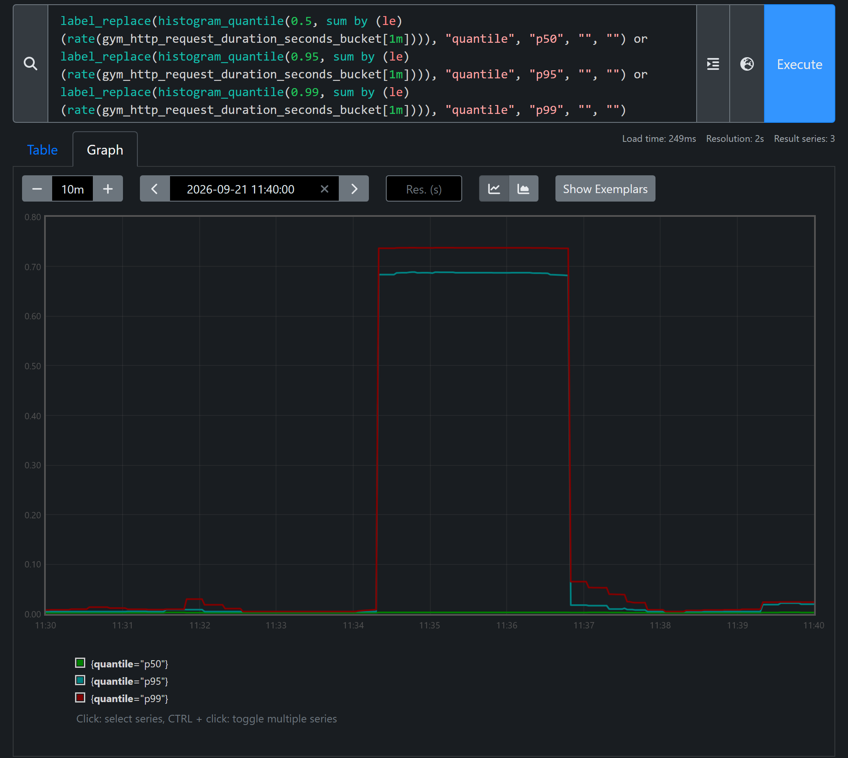
Screenshot 5: Response time before, during and after the fault, in Prometheus: server-side p50, p95 and p99 over a 1-minute window, 11:30 to 11:40 UTC. p95 and p99 jump from about 5 ms to about 690 and 740 ms for exactly the fault stage, then return; p50 stays near the floor.
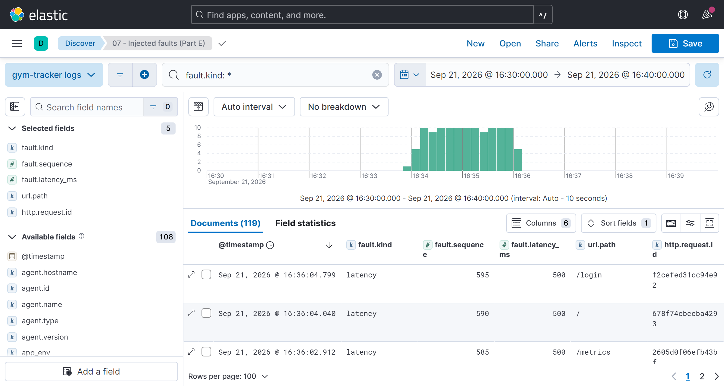
Screenshot 6: Kibana, saved search “07 – Injected faults” (fault.kind: *) across all three stages, 16:30 to 16:40 in the browser’s UTC+5: no fault logs before, one warning per delayed request during the fault, none after. 119 in this range: the 118 in the stage window plus one request just before it began.
Cause and effect on users. Because the delay happens inside the request, every fifth request simply waits an extra half second. That pushed p95 from 4.8 ms to 687.5 ms, about 143 times higher. Meanwhile p50 barely moved and nothing failed, so an uptime check or error-rate alert would have stayed green the whole time. Users would still notice, though. One page load makes several requests, so most page loads would hit at least one slow one. Throughput also dropped 32% (4.98 → 3.38 requests/s) because each request took longer. p95 reads 687 ms rather than 500 because histogram_quantile estimates inside the 0.5 to 0.75 s bucket, not because the delay was any bigger.
Recovery. After switching the fault off and restarting, the same test gave p95 5.6 ms and no fault logs, so everything went back to normal.

E2: Cardinality explosion
This experiment shows why something like a request ID should never go on a metric. It uses a separate small app, observability/cardinality_demo.py, with two counters: demo_requests_total labelled by endpoint and request_id (capped at 100 unique IDs), and demo_requests_safe_total labelled by endpoint only. I sent requests in steps and checked Prometheus after each step. Then I restarted the demo in safe mode without the request_id label, repeated the requests, and checked again two scrapes later.
Each call to curl http://localhost:8001/demo creates one new request ID. Safe mode is started with CARDINALITY_SAFE_ONLY=true docker compose --profile experiment up -d --force-recreate cardinality-demo.
Unique IDs sent | 1 | 10 | 25 | 50 | 100 | 120 | label removed, 2 scrapes later
count(demo_requests_total) | 1 | 10 | 25 | 50 | 100 | 100 | no data
count(demo_requests_safe_total) | 1 | 1 | 1 | 1 | 1 | 1 | 1

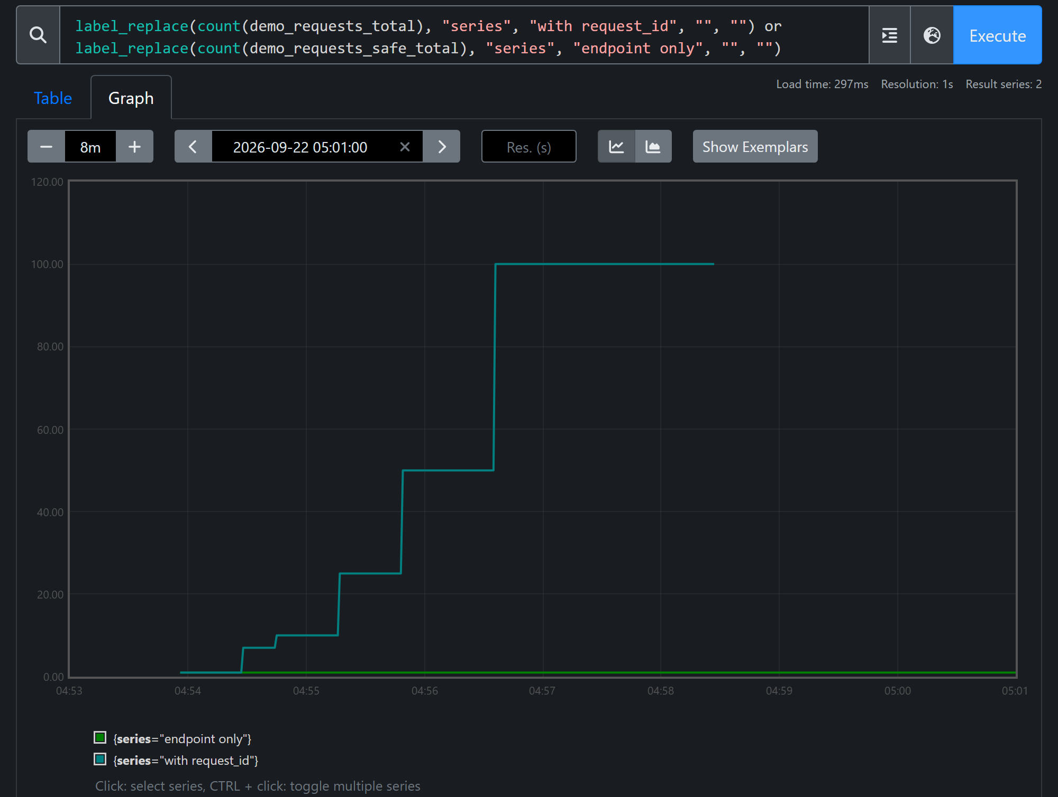
Screenshot 7: count(demo_requests_total) in Prometheus climbing 1 → 10 → 25 → 50 → 100 as IDs are sent, holding at 100 when 120 are sent (the cap), and ending when the demo restarts without the label at 04:58 UTC. The endpoint-only counter stays at 1 throughout (22 September).
History is not deleted. Removing the label doesn't erase what's already there. Evaluated at 04:57:30 UTC, before the restart, the same query still returns 100, because the old series stay on disk until the 15-day retention clears them. Only queries about the present stop seeing them.
Cost at scale, and why IDs belong in logs. Every new request ID creates a brand-new time series, and each one takes up memory and index space in Prometheus. At 100 requests per second, that's 8.64 million new series a day, far more than one Prometheus server can hold. It would run out of memory and take all of the monitoring down with it. A request ID is only useful for finding one particular request, and logs already do that cheaply. So in this project the request ID goes on every log line but never on a metric, and a test fails if an ID-like label is ever added.

Submission and credits
Submitted: the repository (code and configuration, including docker-compose.yml, observability/ with the Prometheus config and alert rules, Grafana dashboards, Filebeat and Elasticsearch config, and the Kibana saved searches), README.md with start, use, test and clean-up instructions, and this report. docs/REPORT.md holds the full technical write-up.
Credits. The application is my own prior work. Claude (Anthropic) was used to implement the observability layer, the compose stack, the dashboards and the reports, working from the brief and the existing code; all of it was reviewed, and the experiments were run and their results recorded. Sources: Prometheus, Grafana and Elastic documentation; Lab 1: Midnight Launch as a reference.

